**Setting Property Location**

We use google to search and locate your property so having the correct location on the system, this will help with searches and indeed for your clients to find your property.

If you are in the property, you can simply click the location arrow on the right of the location box.



You will then be asked by the site to allow your location to be added to the site.

If you are not at the property, please head over to

<https://www.google.com/maps>

Locate your villa on the map and click once on your villa or nearest road

Then click on the information panel Les Courtines above this will then bring up a information bar on the left. Here you will see the information about the selected location

You then need to copy the location by hovering your mouse over the location/address so the copy icon appears.

Then paste this address in to the Location box on French Vacations

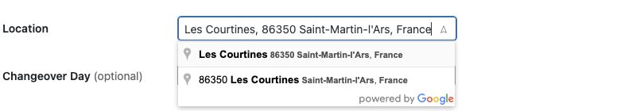

And select from the Google recommendations above save the property and your locations should be correctly stored on your advert.

If you have any problems with this please send your address or coordinates to [steve@frenchvacations.co.uk](mailto:steve@frenchvacations.co.uk) and I will be happy to do this for you.

Thanks

The French Vacations Team.