

Calendar Blocking & Unblocking Dates

To View the Calendar

Login to the site using your username and password, once logged in click on the listings this will only show once a property as been added to your profile.

Then simply click on the calendar if you need to block dates or add prices as below.

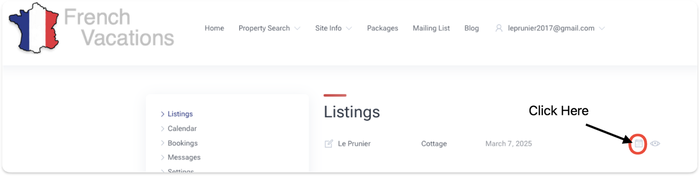

To block a booking on the site simply click on the first day of the booking and drag your mouse cursor highlighting the required days then click on the closed padlock to Block. Once Blocked the selected dates will change colour. The availability on the website will now be set so no booking will be accepted on these dates. To unblock a booking select all dates in the booking and click the open padlock.

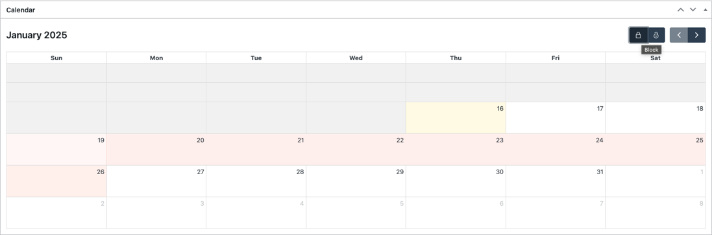

Setting Pricing

Pricing is set on the Calendar on a per day basis if you have a weekly price you will need to divide this by 7. Select you date range and once the selected dates are highlighted you will see a price sticker appear on the calendar tool bar.

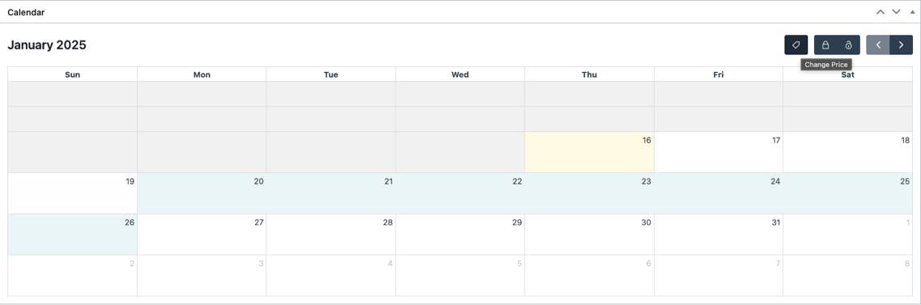

If you click this, it will allow you to input a price for the selected dates
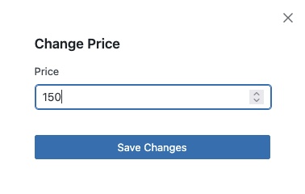
Once you click Save changes the price will be updated on the calendar you will need to refresh to see the changed dates.

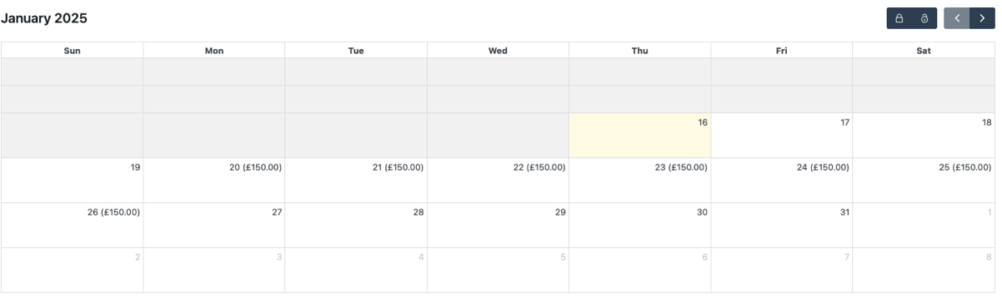

If you have any issues or need help with the functionality of the calendar, please contact steve@frenchvacations.co.uk

